Task on RDS

Task 1: Create MariaDB Database on EC2
Objective
To create and configure a MariaDB database server on an Amazon EC2 instance, start the MariaDB service, secure the database installation, and verify that the database is accessible and functioning correctly.

Step-by-Step Process / Implementation
Step 1: Launch an EC2 Instance
- Sign in to the AWS Management Console.
- Navigate to EC2 → Instances.
- Click Launch instances.
- Configure the instance:
  - Name: MariaDB-Server
  - AMI: Amazon Linux 2023
  - Instance type: t2.micro or t3.micro
  - Key pair: Select the required key pair.
  - Network: Use the required VPC and subnet.
- Configure the Security Group.
- Allow SSH (TCP 22) from My IP.
- Launch the instance.
Step 2: Connect to the EC2 Instance
From Git Bash/terminal, connect using SSH:
ssh -i "your-key.pem" ec2-user@<PUBLIC-IP>
Verify that you are connected:
hostname

Step 3: Update the Package Repository
Run:
sudo dnf update -y
This updates the installed packages and package repository information.

Step 4: Install MariaDB
Install the MariaDB server package:
sudo dnf install mariadb105-server -y
Verify the installation:
mariadb --version
You should see the installed MariaDB version.

Step 5: Start the MariaDB Service
Start MariaDB:
sudo systemctl start mariadb
Enable MariaDB to start automatically when the EC2 instance boots:
sudo systemctl enable mariadb
Check the service status:
sudo systemctl status mariadb
The service should show:
active (running)

Step 6: Secure the MariaDB Installation
Run:
sudo mysql_secure_installation
Follow the prompts to improve the security of the MariaDB installation.
Depending on the MariaDB version, the prompts may include:
- Setting or confirming the root authentication method/password
- Removing anonymous users
- Disallowing remote root login
- Removing the test database
- Reloading privilege tables
Choose the appropriate secure options for the lab.

Step 7: Log in to MariaDB
Connect to the database:
sudo mariadb
You should enter the MariaDB command-line interface.
Example:
MariaDB [(none)]>

Step 8: Create a Database
Create a sample database:
CREATE DATABASE testdb;
Verify that it was created:
SHOW DATABASES;
You should see:
testdb

Step 9: Create a Database User
Create a dedicated user:
CREATE USER 'dbuser'@'localhost' IDENTIFIED BY 'YourStrongPassword@123';
Grant privileges:
GRANT ALL PRIVILEGES ON testdb.* TO 'dbuser'@'localhost';
Apply the privileges:
FLUSH PRIVILEGES;
Verify the user:
SELECT User, Host FROM mysql.user;

Step 10: Test the Database
Select the database:
USE testdb;
Create a sample table:
CREATE TABLE employees (
id INT PRIMARY KEY,
name VARCHAR(50),
department VARCHAR(50)
);
Insert sample data:
INSERT INTO employees VALUES
(1, 'John', 'IT'),
(2, 'Alice', 'HR');
Verify the data:
SELECT * FROM employees;
Expected result:
+----+-------+------------+
| id | name | department |
+----+-------+------------+
| 1 | John | IT |
| 2 | Alice | HR |
+----+-------+------------+
Exit MariaDB:
EXIT;

3. Evidence / Screenshots
Capture the following screenshots for the report:
Screenshot 1 – EC2 Instance
Show the EC2 instance with:
- Instance name
- Instance ID
- Running state
- Public/Private IP
- Instance type
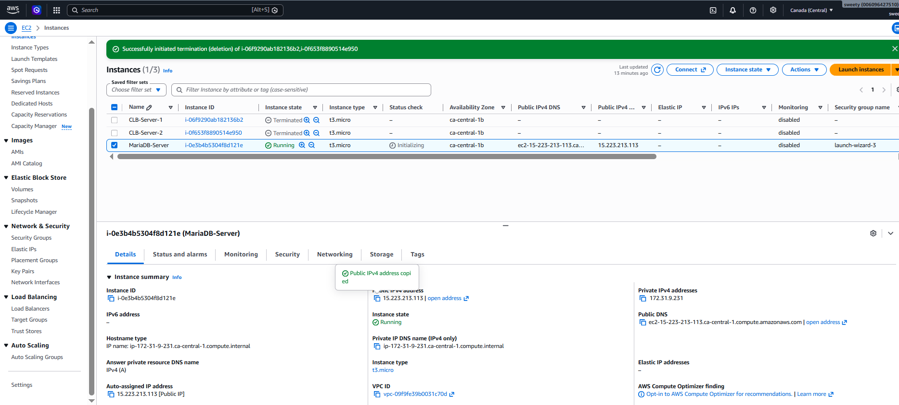
Screenshot 2 – MariaDB Installation
Show the terminal command:
sudo dnf install mariadb105-server -y
and the successful installation output.

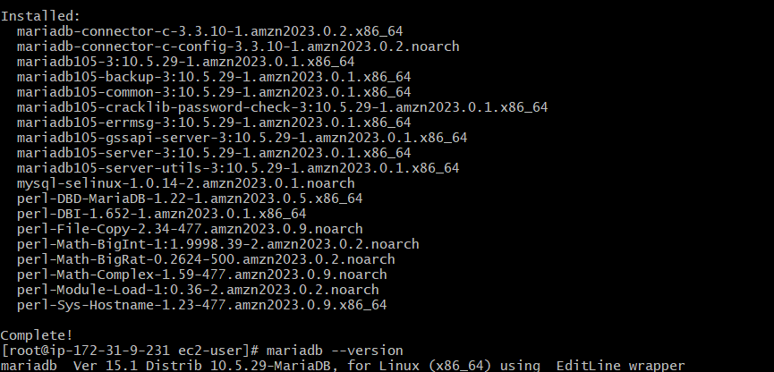
Screenshot 3 – MariaDB Service Status
Show:
sudo systemctl status mariadb
The screenshot should clearly show:
Active: active (running)
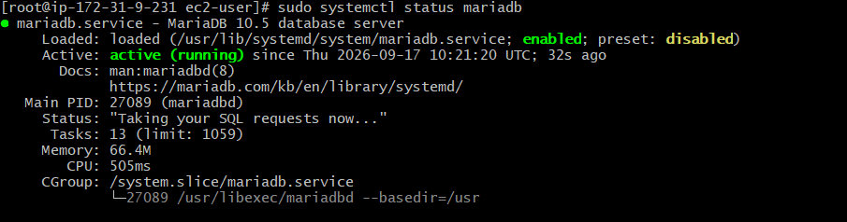
Screenshot 4 – MariaDB Version
Show:
mariadb --version
This provides evidence that MariaDB was successfully installed.
Screenshot 5 – Database Creation
Show the MariaDB terminal with:
CREATE DATABASE testdb;
SHOW DATABASES;
The testdb database should be visible.
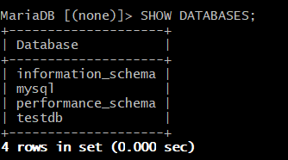
Screenshot 6 – Table and Data Verification
Show:
USE testdb;
SELECT * FROM employees;
The inserted employee records should be visible.
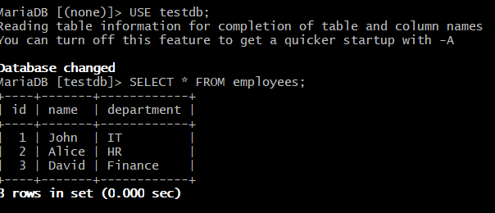

4. Conclusion
The MariaDB database server was successfully installed and configured on an Amazon EC2 instance. The MariaDB service was started and enabled for automatic startup. A database named testdb, a dedicated database user, and an employees table were created successfully. Sample records were inserted and retrieved to verify that the MariaDB database was functioning correctly.

Task 2: Insert Dummy Data
Objective
To insert sample/dummy records into the employees table in the MariaDB database and verify that the data has been stored successfully.
Steps / Implementation
Step 1: Connect to MariaDB
From the Linux shell:
sudo mariadb
You should see:
MariaDB [(none)]>
Step 2: Select the testdb database
At the MariaDB prompt:
USE testdb;
Expected:
Database changed
Step 3: Insert dummy data
Run:
INSERT INTO employees (id, name, department)
VALUES
(4, 'Robert', 'IT'),
(5, 'Emma', 'HR'),
(6, 'Michael', 'Finance'),
(7, 'Sophia', 'Marketing'),
(8, 'Daniel', 'Sales');
Expected:
Query OK, 5 rows affected
Step 4: Verify the inserted data
Run:
SELECT * FROM employees;
You should see the existing records plus the newly inserted records:
+----+--------+------------+
| id | name | department |
+----+--------+------------+
| 1 | John | IT |
| 2 | Alice | HR |
| 3 | David | Finance |
| 4 | Robert | IT |
| 5 | Emma | HR |
| 6 | Michael| Finance |
| 7 | Sophia | Marketing |
| 8 | Daniel | Sales |
+----+--------+------------+
Evidence Screenshots
Take these screenshots for the report:
- Database selection
  - Show USE testdb;
  - Show Database changed.
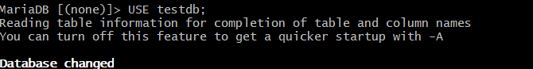
- Dummy data insertion
  - Show the INSERT INTO employees... command.
  - Capture the Query OK result.
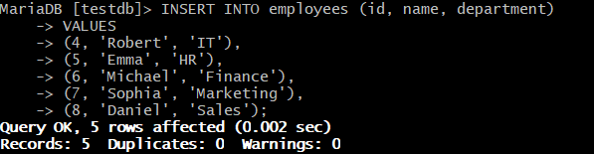
- Data verification — strongest evidence
  - Show:
SELECT * FROM employees;
  - Make sure the newly inserted records are visible.
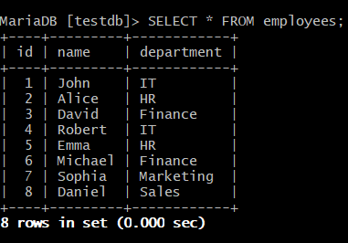
Conclusion
The dummy employee data was successfully inserted into the employees table in the testdb database. The inserted records were retrieved using a SELECT query, confirming that the data was stored successfully in MariaDB.

Task 3: Take Backup of Dummy Data on EC2
1. Objective
To take a backup of the testdb MariaDB database containing the dummy employee data and store the backup file on the Amazon EC2 instance.
2. Steps / Implementation
Step 1: Access the MariaDB Database
The MariaDB database was accessed using:
sudo mariadb
The testdb database was selected:
USE testdb;
Step 2: Verify Dummy Data
The employee records were verified using:
SELECT * FROM employees;
The table contained 8 employee records.
Step 3: Exit MariaDB
The MariaDB session was exited using:
EXIT;
Step 4: Create a Backup Directory
A directory named /backup was created on the EC2 instance:
mkdir -p /backup
Step 5: Create the Database Backup
The mysqldump utility was used to back up the testdb database:
mysqldump -u root -p testdb > /backup/testdb_backup.sql
The command completed successfully and created the SQL backup file.
Step 6: Verify the Backup File
The backup file was verified using:
ls -lh /backup/testdb_backup.sql
The output confirmed that the file was successfully created:
-rw-r--r--. 1 root root 2.2K Sep 17 12:00 /backup/testdb_backup.sql
The backup file size was approximately 2.2 KB.
Step 7: Verify Backup Contents
The beginning of the backup file was checked using:
head -20 /backup/testdb_backup.sql
The output confirmed that the file contained the MariaDB dump information and the employees table structure.
The actual employee records were verified using:
grep -A10 "INSERT INTO" /backup/testdb_backup.sql
The output showed all 8 employee records:
INSERT INTO `employees` VALUES
(1,'John','IT'),
(2,'Alice','HR'),
(3,'David','Finance'),
(4,'Robert','IT'),
(5,'Emma','HR'),
(6,'Michael','Finance'),
(7,'Sophia','Marketing'),
(8,'Daniel','Sales');
3. Evidence Screenshots
Screenshot 1 – Database and Dummy Data Verification
Capture the MariaDB terminal showing:
SELECT * FROM employees;
The screenshot should clearly show all 8 employee records.
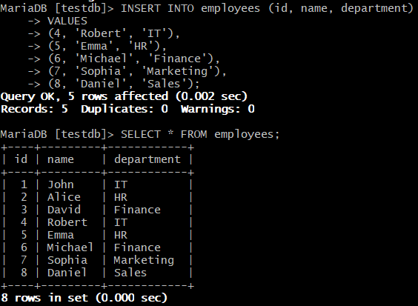
Screenshot 2 – Backup Creation
Capture the terminal showing:
mysqldump -u root -p testdb > /backup/testdb_backup.sql
followed by the successful return to the Linux shell.

Screenshot 3 – Backup File Verification
Capture:
ls -lh /backup/testdb_backup.sql
The screenshot should show the testdb_backup.sql file and its size of approximately 2.2 KB.
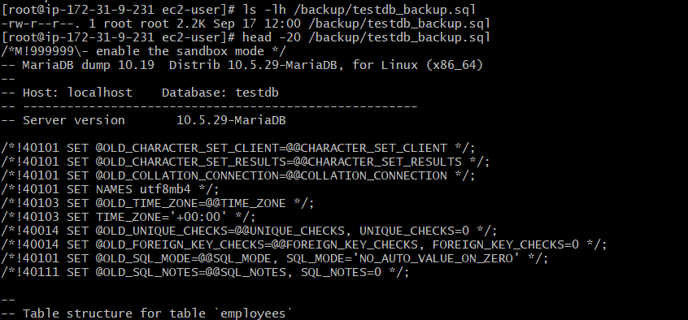
Screenshot 4 – Backup Data Verification
Capture:
grep -A10 "INSERT INTO" /backup/testdb_backup.sql
This screenshot should show the employee records stored inside the SQL backup file.
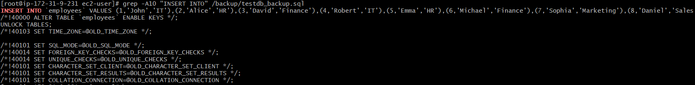
4. Conclusion
The testdb MariaDB database was successfully backed up on the Amazon EC2 instance using the mysqldump utility. The backup was stored as /backup/testdb_backup.sql and its existence and contents were verified successfully. The backup file contains the employees table structure and all 8 dummy employee records, confirming that the database backup was created successfully.

Task 4: Launch MariaDB RDS Instance
1. Objective
To launch a MariaDB database instance using Amazon Relational Database Service (Amazon RDS) and verify that the RDS instance is successfully available.
2. Steps / Implementation
Step 1: Open Amazon RDS
- Logged in to the AWS Management Console.
- Opened Amazon RDS.
- Navigated to RDS → Databases.
- Selected Create database.
Step 2: Select Database Engine
Under Engine options, selected:
- Engine type: MariaDB
- Database creation method: Full configuration
Step 3: Configure the RDS Instance
The RDS instance was configured with:
- DB Instance Identifier: database-1
- Master Username: admin
- Instance Class: db.t4g.micro
- Availability Zone: ca-central-1d
- Region: Canada (Central) (ca-central-1)
- Multi-AZ: No
The database was created using the available Free Tier configuration.
Step 4: Create the Database
After reviewing the configuration, Create database was selected.
Initially, the RDS instance showed the status:
Creating
AWS then applied the required configuration changes.
Step 5: Verify the RDS Instance
After the provisioning process was completed, the status changed to:
Available
The RDS database list confirmed:
DB Identifier: database-1
Status: Available
Engine: MariaDB
Instance Class: db.t4g.micro
Region: ca-central-1
Availability Zone: ca-central-1d
Multi-AZ: No
This confirmed that the MariaDB RDS instance was successfully launched.
3. Evidence Screenshots
Screenshot 1 – RDS Instance Available
This is the main evidence screenshot.
Capture the RDS Databases page showing:
database-1
Status: Available
Engine: MariaDB
db.t4g.micro
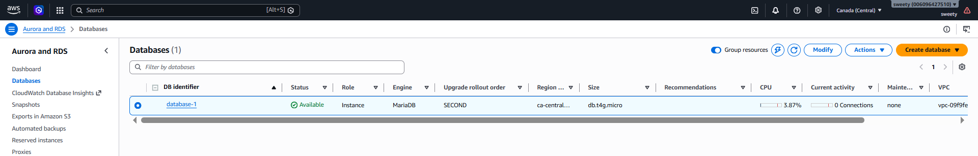
Screenshot 4 – RDS Instance Details
Open database-1 and capture the database details page showing the MariaDB engine and instance configuration.
Do not include or expose the master password in the screenshot.
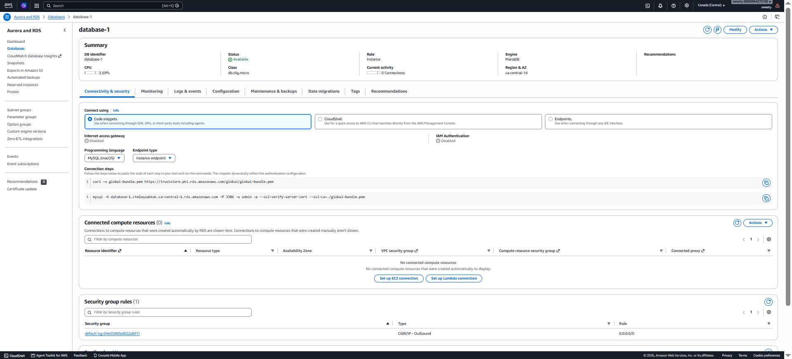
4. Conclusion
A MariaDB database instance was successfully launched using Amazon RDS in the Canada (Central) AWS Region. The instance was configured with the db.t4g.micro instance class and successfully transitioned from Creating to Available status. This confirmed that the MariaDB RDS instance was provisioned and operational.
Task 5: Migrate Database from EC2 to RDS
1. Purpose
The purpose of this task is to migrate the MariaDB database created on an Amazon EC2 instance to a MariaDB database hosted on Amazon RDS. This demonstrates how a self-managed database can be migrated to a managed AWS database service.
2. Objective
To migrate the testdb MariaDB database from the EC2 instance to the MariaDB RDS instance using the database backup created in the previous task, and verify that the database and employee records are available on RDS.
3. Steps to Achieve the Task
Step 1: Verify the Source Database on EC2
Step 2: Verify the Database Backup
Step 3: Verify the RDS MariaDB Instance
Step 4: Configure RDS Security Group
Step 5: Establish a Secure Connection from EC2 to RDS
Step 6: Create the Target Database on RDS
Step 7: Exit the RDS Connection
Exit MariaDB:
EXIT;
Step 8: Import the EC2 Backup into RDS
mariadb --ssl -h database-1.ctm2oqswkkuk.ca-central-1.rds.amazonaws.com -P 3306 -u admin -p testdb < /backup/testdb_backup.sql
Enter the RDS master password when prompted.
Step 9: Verify the Migrated Database
mariadb --ssl -h database-1.ctm2oqswkkuk.ca-central-1.rds.amazonaws.com -P 3306 -u admin -p
Conclusion
The MariaDB database migration process involves transferring the testdb database from the EC2-hosted MariaDB server to the MariaDB RDS instance. The EC2 backup file created in the previous task is used as the migration source. The RDS security group is configured to allow database connectivity from the EC2 instance, and an encrypted SSL/TLS connection is required by the RDS instance.

Task 6: Install MySQL Database on EC2
1. Purpose
The purpose of this task is to install and configure a MySQL database server on an Amazon EC2 instance and verify that the MySQL service is functioning correctly.
2. Objective
To install MySQL Server on an Amazon Linux EC2 instance, start and enable the MySQL service, and verify that the MySQL database server is installed and operational.
3. Steps to Achieve the Task
Step 1: Launch an EC2 Instance
- Open the AWS Management Console.
- Navigate to EC2 → Instances.
- Launch a new EC2 instance.
- Select Amazon Linux 2023 as the operating system.
- Select an appropriate small instance type such as t3.micro or the Free Tier eligible option available in your account.
- Configure the required key pair.
- Use the default VPC and subnet unless your assignment specifies otherwise.
- Launch the instance.
Step 2: Connect to the EC2 Instance
Connect to the new instance using SSH.
From Git Bash on Windows, use:
ssh -i your-key.pem ec2-user@<EC2-PUBLIC-IP>
After connecting, you should see a prompt similar to:
[ec2-user@ip-xxxxxxxxx ~]$
Step 3: Switch to Root User
Run:
sudo su
The prompt should change to:
[root@ip-xxxxxxxxx ~]#
Step 4: Update the Package Repository
Run:
dnf update -y
This updates the installed packages and package repository information.
Step 5: Install MySQL
On Amazon Linux 2023, first check the available MySQL packages:
dnf list available | grep -i mysql
Then install the MySQL server package available for the instance:
dnf install mysql-server -y
If mysql-server is not available, do not install a random package. Record the exact error and check the available MySQL module/package provided by the Amazon Linux repositories.
Step 6: Start the MySQL Service
Start the MySQL service:
systemctl start mysqld
Step 7: Enable MySQL at Boot
Run:
systemctl enable mysqld
This ensures that MySQL starts automatically when the EC2 instance is rebooted.
Step 8: Check MySQL Service Status
Run:
systemctl status mysqld
The important result is:
Active: active (running)
Press q to exit the status screen.
Step 9: Verify the MySQL Version
Run:
mysql --version
The command should display the installed MySQL version.
Step 10: Log in to MySQL
Run:
mysql
If the MySQL installation requires root authentication, use the appropriate root authentication method configured during installation.
A successful connection will display a prompt similar to:
mysql>
Run:
SHOW DATABASES;
This verifies that the MySQL database server is responding correctly.
Exit MySQL using:
EXIT;
4. Evidence Screenshots
Screenshot 1 – EC2 Instance
Capture the EC2 console showing the newly launched instance in the Running state.
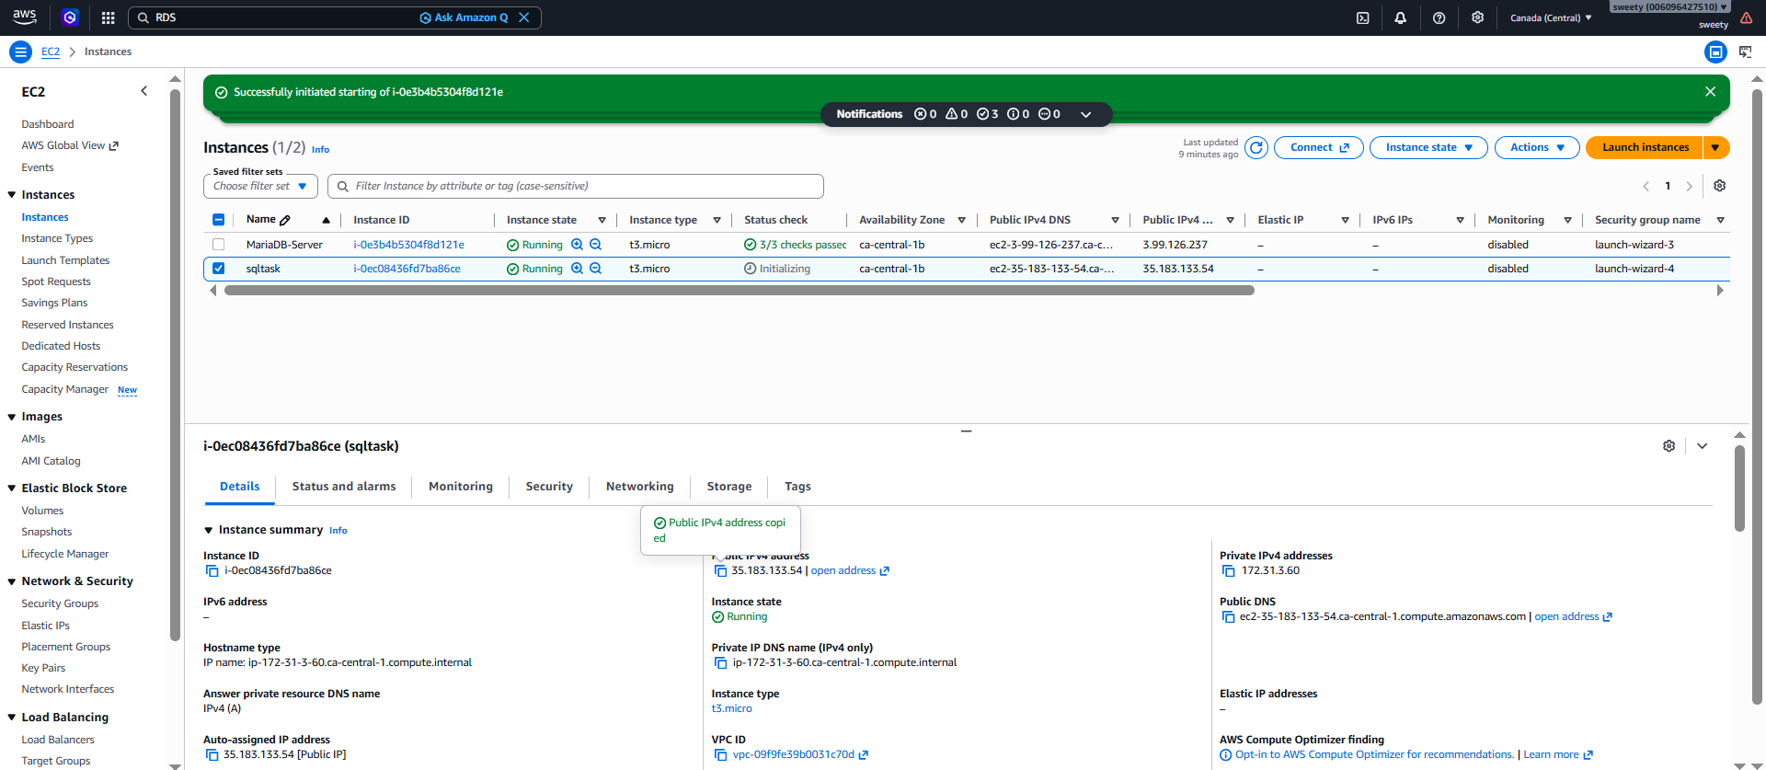
Screenshot 2 – MySQL Installation
Capture the terminal showing:
dnf install mysql-server -y
and the successful installation output.
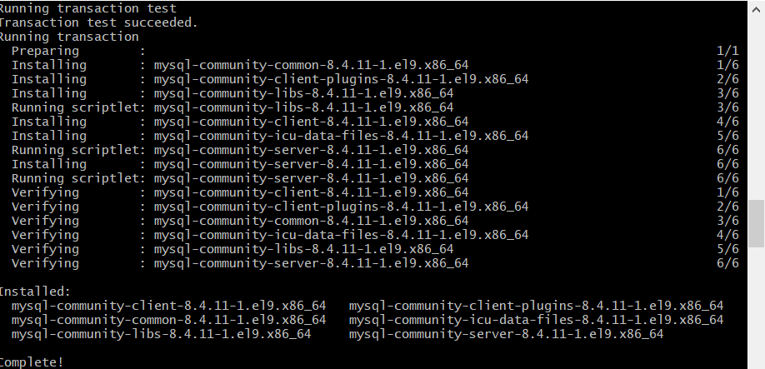
Screenshot 3 – MySQL Service
Capture:
systemctl status mysqld
The screenshot should clearly show:
Active: active (running)
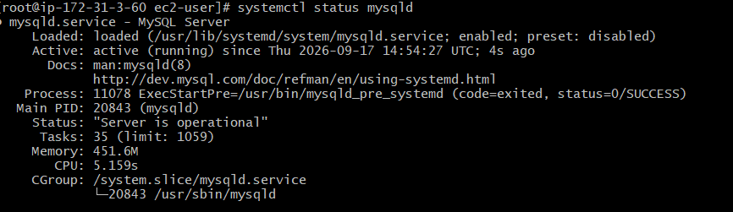
Screenshot 4 – MySQL Version
Capture:
mysql --version
showing the installed MySQL version.
Screenshot 5 – MySQL Database Verification
Capture the MySQL prompt showing:
SHOW DATABASES;
This confirms that the MySQL server is operational.
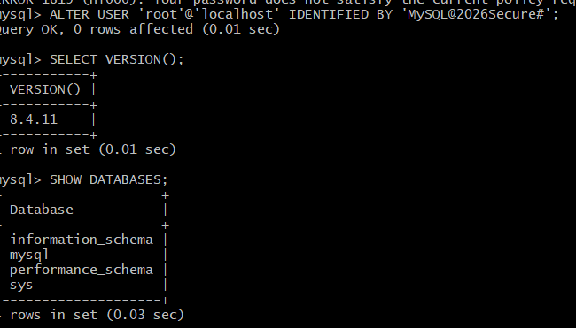
5. Conclusion
MySQL Server was successfully installed on an Amazon EC2 instance. The MySQL service was started and configured to start automatically during system boot. The service status and MySQL version were verified, and a successful connection to the MySQL database server confirmed that the installation was functioning correctly.

Task 7: Launch MySQL RDS Database
1. Purpose
The purpose of this task is to create and configure an Amazon RDS MySQL database using AWS managed database services.
Amazon RDS simplifies database management by handling tasks such as infrastructure provisioning, storage management, backups, monitoring, and maintenance.

2. Objective
The objectives of this task are to:
- Launch a MySQL database using Amazon RDS.
- Configure the database using the db.t4g.micro instance class.
- Configure database storage.
- Verify the database availability.
- Verify the database endpoint and port.
- Verify VPC and security group configuration.
- Verify the MySQL engine version and Availability Zone.

3. Implementation Steps
Step 1: Open Amazon RDS
- Log in to the AWS Management Console.
- Select the Canada (Central) region.
- Search for RDS.
- Open Amazon Aurora and RDS.
- Select Databases.

Step 2: Create the RDS Database
- Click Create database.
- Select the appropriate database creation method.
- Select MySQL as the database engine.
- Configure the database instance.
- Specify the DB identifier as:
database-2
- Configure the instance class as:
db.t4g.micro
- Configure storage with:
  - Storage type: General Purpose SSD (gp2)
  - Storage: 20 GiB
  - Storage autoscaling: Enabled
- Configure the required networking and security settings.
- Configure the database credentials.
- Review the settings.
- Click Create database.

Step 3: Verify Database Status
After the database was created:
- Open RDS → Databases.
- Select database-2.
- Verify that the database status is Available.
- Verify that the engine is MySQL Community.
- Verify that the instance class is db.t4g.micro.
The database was successfully created and became available.

Step 4: Verify Connectivity & Security
Navigate to:
database-2 → Connectivity & security
The following configuration was verified:
Configuration | Value
Endpoint | database-2.ctm2oqswkkuk.ca-central-1.rds.amazonaws.com
Port | 3306
VPC | vpc-09f9fe39b0031c70d
Availability Zone | ca-central-1a
Network Type | IPv4
Security Group | default (sg-04e5586fad822a891)
Publicly Accessible | No
Internet Access Gateway | Disabled
The RDS database therefore uses a private network configuration and is not publicly accessible.

Step 5: Verify Database Configuration
Navigate to:
database-2 → Configuration
The following configuration was verified:
Configuration | Value
DB Instance ID | database-2
Engine | MySQL
Engine Version | 8.4.9
Instance Class | db.t4g.micro
vCPU | 2
RAM | 1 GB
Availability Zone | ca-central-1a
Storage Type | General Purpose SSD (gp2)
Storage | 20 GiB
Storage Encryption | Enabled
Multi-AZ | No
Storage Autoscaling | Enabled
Maximum Storage Threshold | 1000 GiB

4. Evidence
Evidence 1: RDS Database Status
The screenshot shows:
- DB identifier: database-2
- Status: Available
- Engine: MySQL Community
- Instance class: db.t4g.micro
- Region & AZ: ca-central-1a
Figure 7.1: RDS database-2 showing Available status, MySQL engine, and db.t4g.micro instance class.
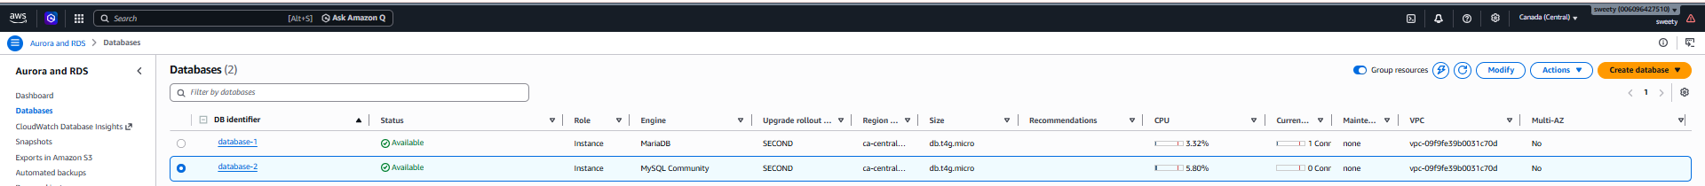
Evidence 2: Connectivity & Security
The screenshot shows:
- RDS endpoint
- Port 3306
- VPC ID
- Subnet information
- Security group
- Publicly accessible: No
- IPv4 network configuration
Figure 7.2: database-2 Connectivity & Security configuration showing the RDS endpoint, port 3306, VPC, security group, and private accessibility configuration.
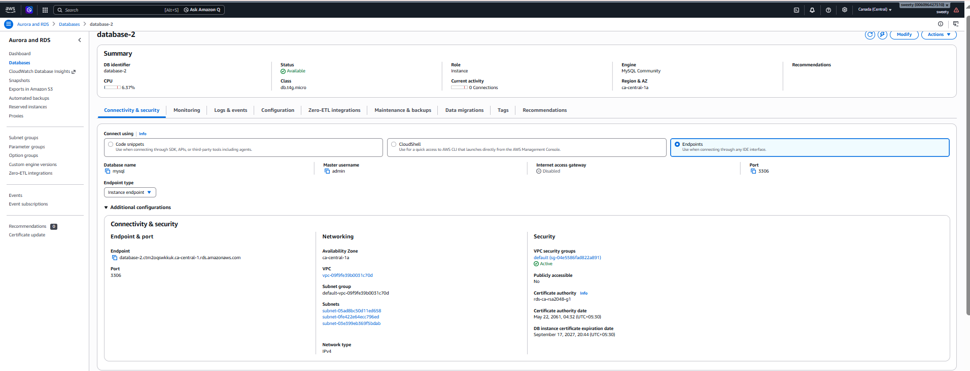
Evidence 3: Database Configuration
The screenshot shows:
- MySQL version 8.4.9
- Instance class db.t4g.micro
- Storage 20 GiB
- Storage type gp2
- Availability Zone ca-central-1a
- Encryption enabled
- Multi-AZ disabled

Figure 7.3: database-2 Configuration showing MySQL 8.4.9, db.t4g.micro instance class, 20 GiB storage, and Availability Zone ca-central-1a.
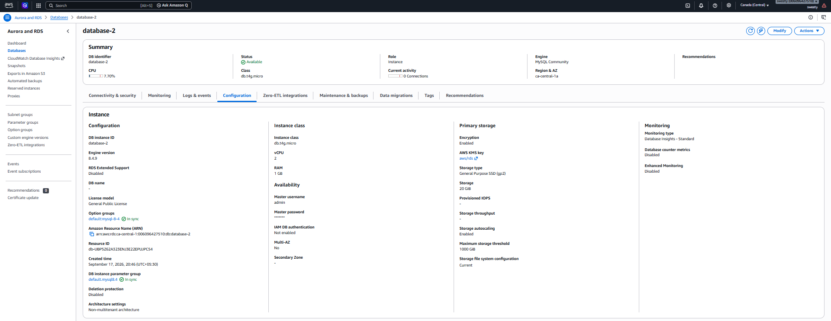
5. Conclusion
The MySQL RDS database database-2 was successfully created and verified in the Canada (Central) region.
The database is in Available status and uses the MySQL 8.4.9 engine with a db.t4g.micro instance class. It has 20 GiB of gp2 storage, is located in Availability Zone ca-central-1a, and has storage encryption enabled.
The connectivity configuration was also verified, including the database endpoint, port 3306, VPC, and security group. The database is configured as not publicly accessible, providing a private network configuration.

Task 8: Configure Multi-AZ
1. Purpose
The purpose of this task is to configure Multi-AZ deployment for the Amazon RDS MySQL database to improve database availability and provide a standby database instance in a separate Availability Zone.

2. Objective
The objectives of this task are to:
- Open the existing RDS MySQL database database-2.
- Access the database modification settings.
- Locate the Availability & durability configuration.
- Attempt to enable Multi-AZ deployment.
- Verify whether the Multi-AZ option is available for the RDS database.

3. Implementation Steps
Step 1: Open the RDS Database
- Log in to the AWS Management Console.
- Select the Canada (Central) region.
- Open Aurora and RDS.
- Select Databases.
- Select the RDS instance:
database-2

Step 2: Open Modify DB Instance
- Click Modify.
- The Modify DB instance: database-2 page was displayed.
- Verify that the existing database configuration was retained.
The existing configuration included:
- DB instance identifier: database-2
- Engine version: MySQL 8.4.9
- Instance class: db.t4g.micro
- Storage: 20 GiB
- Storage type: General Purpose SSD (gp2)

Step 3: Locate Multi-AZ Configuration
Under Availability & durability, the following options were displayed:
- Create a standby instance
- Do not create a standby instance
The Create a standby instance option was not selectable in the current AWS environment.
The AWS console also displayed a notification indicating that the account was using the Free Plan with limited RDS and Aurora features and resources.

Step 4: Verify the Restriction
The Multi-AZ configuration was checked to determine whether a standby instance could be created.
The option to create a standby instance was unavailable, so the existing database configuration was not modified.
No changes were made to:
- DB instance class
- Storage
- MySQL version
- Network configuration
- Security group
- Backup configuration

4. Evidence
Evidence 1: Modify DB Instance – Availability & Durability
The AWS RDS modification page shows the Availability & durability section for database-2.
It displays the Multi-AZ options, including the option to create a standby instance. However, the standby option is not selectable in the current AWS environment.
Figure 8.1: RDS database-2 Modify DB Instance page showing the Availability & durability and Multi-AZ deployment options.
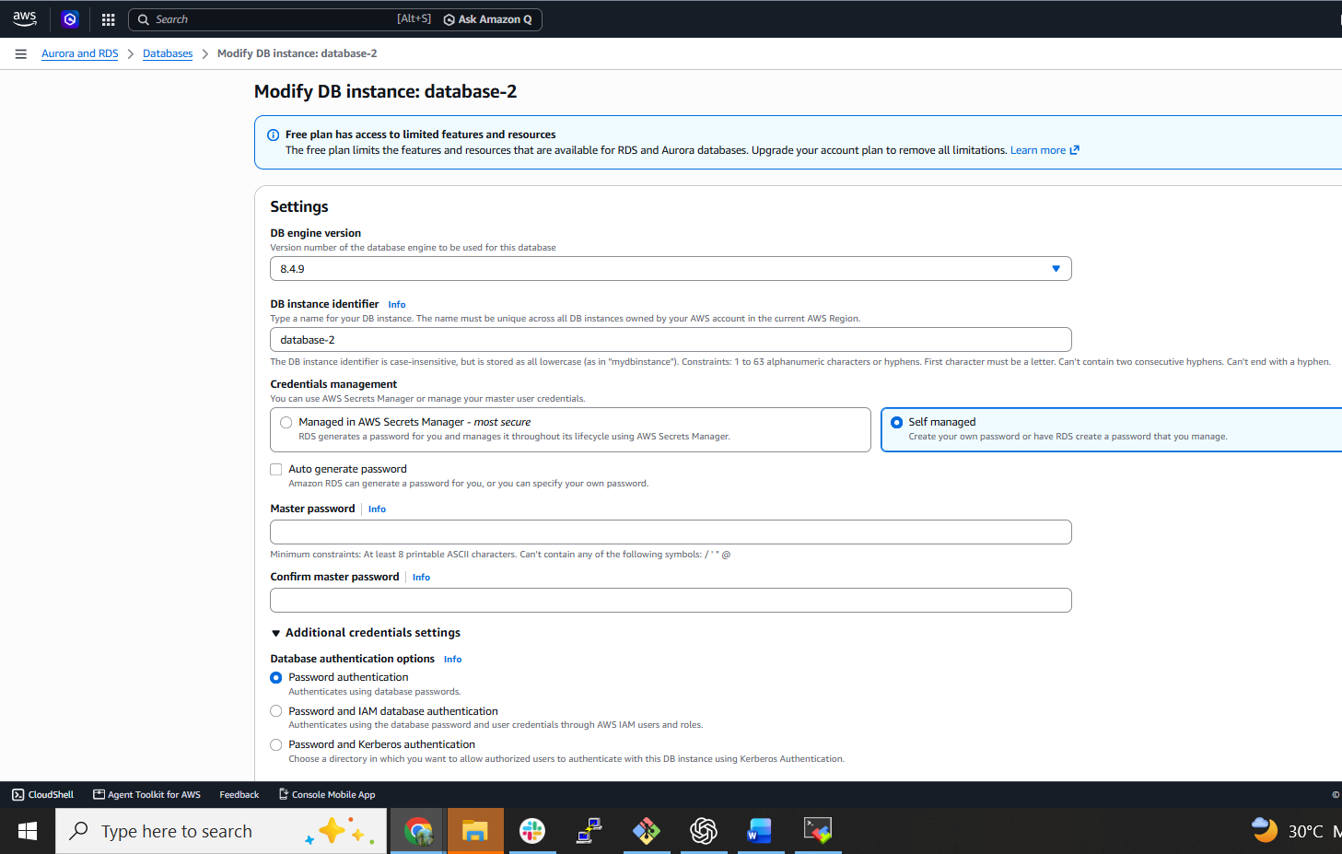
Evidence 2: AWS Free Plan Restriction
The modification page displays the following notification:
Free plan has access to limited features and resources
This indicates that the current RDS environment has feature/resource limitations.
Figure 8.2: AWS RDS Free Plan notification showing limitations on available RDS and Aurora features and resources.

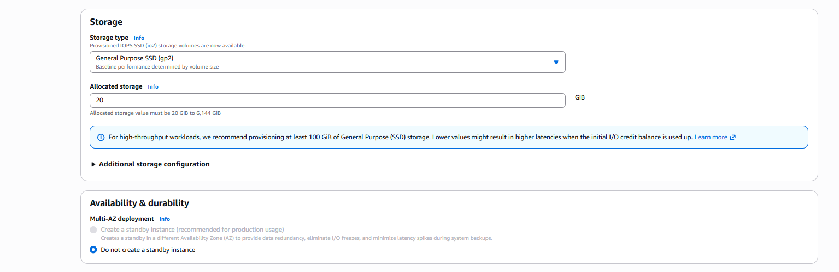
5. Result
The Multi-AZ configuration was attempted but could not be enabled because the Create a standby instance option was unavailable in the current AWS environment.
The existing RDS instance database-2 was therefore left unchanged.
The database remains configured as a single-AZ RDS instance.

6. Conclusion
The Multi-AZ configuration for the MySQL RDS instance database-2 was investigated through the RDS Modify DB instance settings.
The Create a standby instance option was unavailable under the current AWS Free Plan environment. Therefore, Multi-AZ could not be enabled, and no changes were made to the existing database configuration.

Task 9: Backup and Restore RDS Database
Purpose
To create a backup of the RDS MySQL database and restore it when required.
Objective
- Create a manual snapshot of database-2.
- Verify the backup.
- Attempt to restore the database from the snapshot.
Implementation Steps
- Open RDS → Databases → database-2.
- Select Actions → Take snapshot.
- Created the snapshot: database-2-backup.
- Verified the snapshot under RDS → Snapshots → Manual snapshots.
- Attempted to restore the snapshot as a new DB instance.
- Restore was blocked because the Free Plan had reached its maximum RDS instance limit.
Evidence
- Figure 9.1: database-2-backup manual snapshot successfully created.
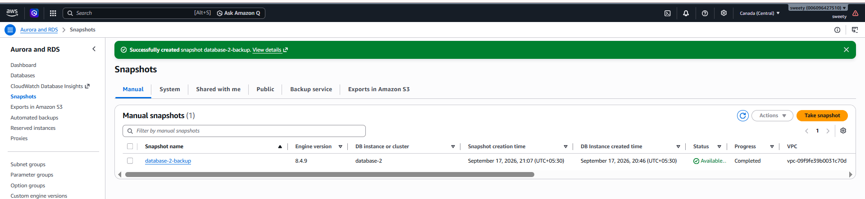

- Figure 9.2: AWS Free Plan instance-limit message during restore.
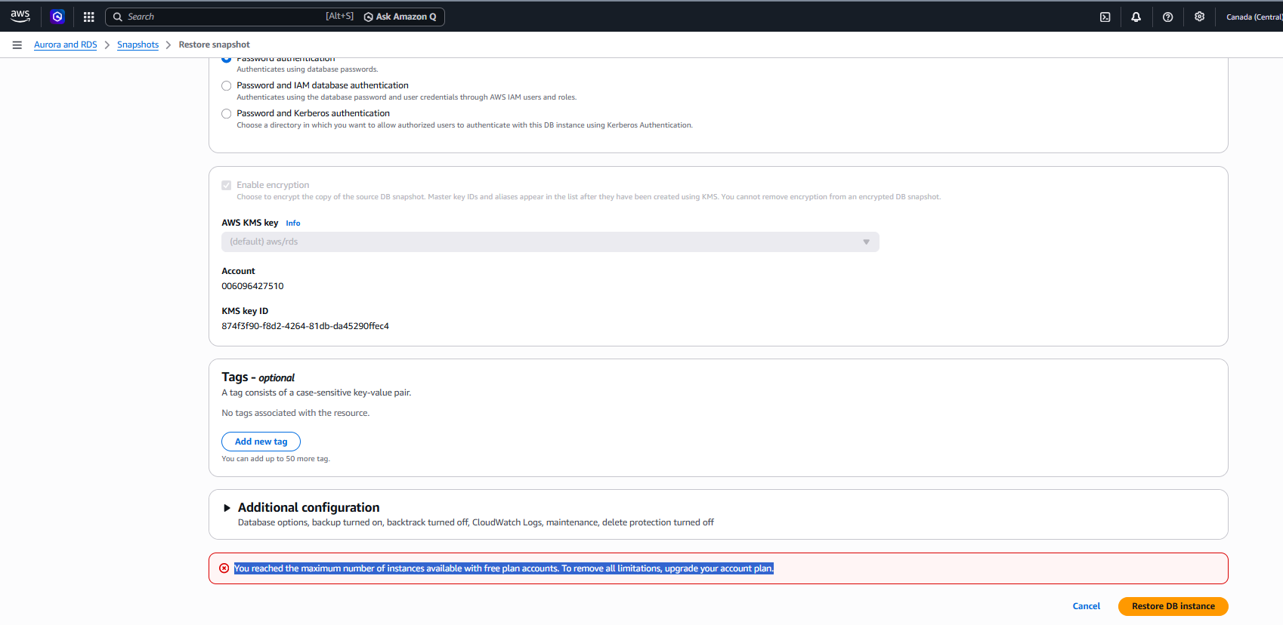
Conclusion
The RDS backup was successfully created. The restore operation was attempted but could not be completed due to the AWS Free Plan RDS instance limit.

Task 10: Create Read Replica
For this task, we'll attempt to create a Read Replica of database-2.
Steps
- Go to RDS → Databases.
- Select database-2.
- Click Actions → Create read replica.
- Enter a new identifier, for example:
database-2-read-replica
- Keep the existing configuration where possible.
- Click Create read replica.
- Wait for the replica status to become Available.
Evidence
Take screenshots showing:
- database-2 as the source database.
- Create read replica configuration page.
- The read replica, if successfully created, showing:
  - DB identifier
  - Status
  - Source DB
  - MySQL engine
  - Instance class
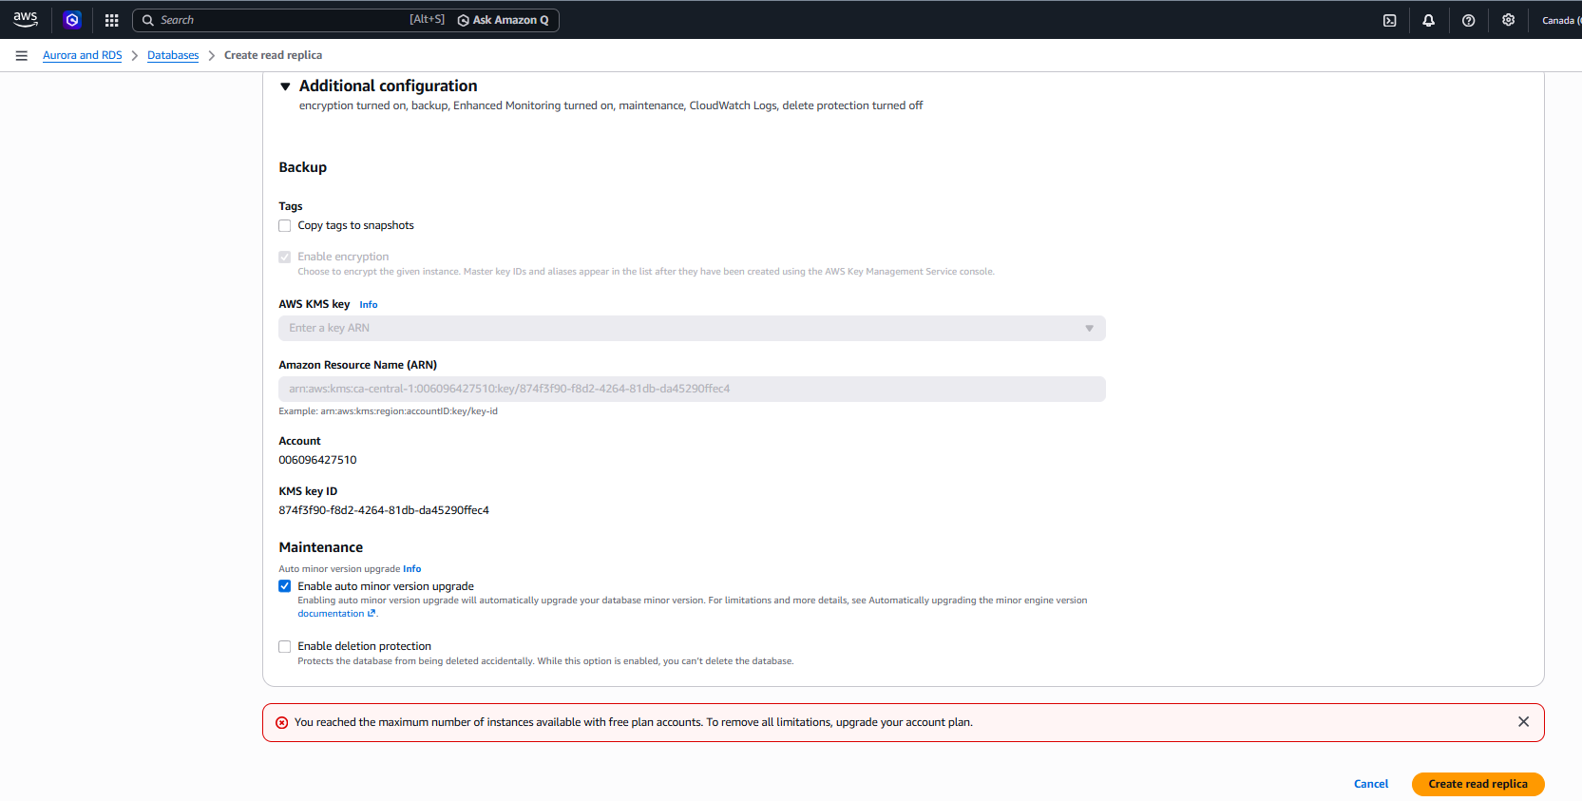
Conclusion
The Read Replica creation was attempted for the RDS database database-2. However, it could not be completed because the AWS Free Plan had reached its maximum RDS instance limit.

